T-Shirt Order
Third grade teachers will be placing an order for Michigan Great Lakes t-shirts. The cost is $7.00 per shirt. The shirts are 100% cotton.
(Our models are wearing a youth medium.)
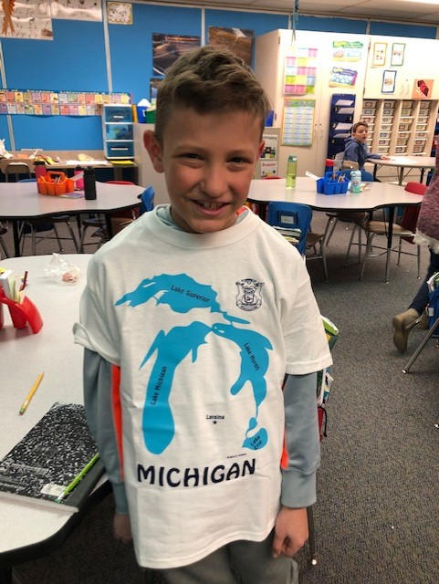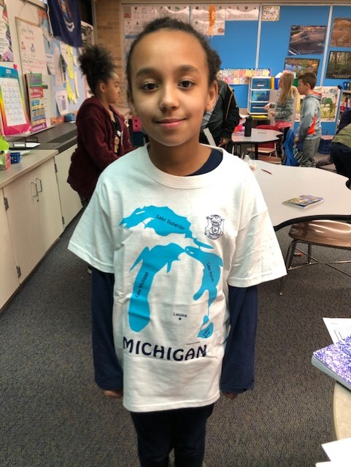

Orders are due Friday, March 13.

Student’s Name___________________________________ Date____________________________
Teacher_________________________________________________
Size | Quantity |  | Cost | Total Cost
Youth small (6-8) |  | X | $6.00
Youth medium (10-12) |  | X | $6.00
Youth large (14-16) |  | X | $6.00
Adult small |  | X | $6.00

