Green BTCB-$10

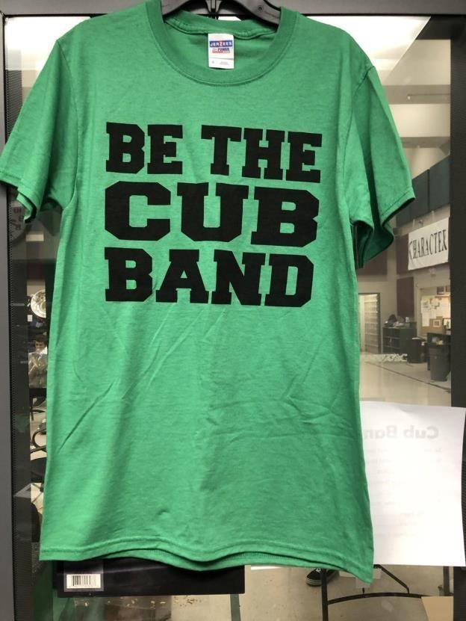

Gray BTCB-$13 (Optional)

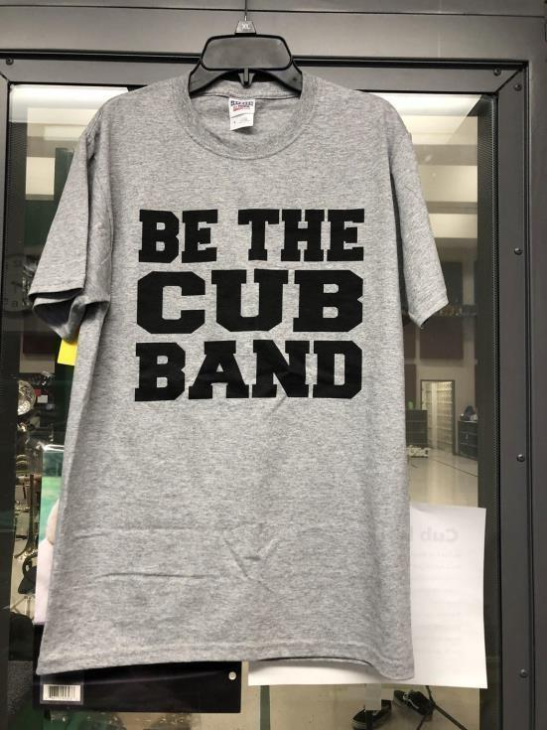

BTCB Alumni-$10

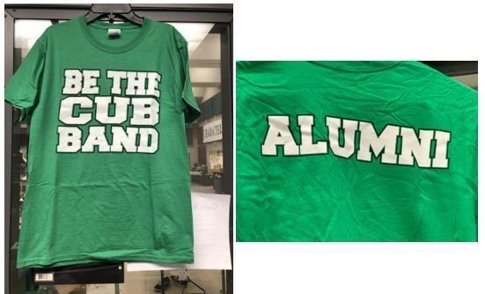

Under The Uniform Shirts-$30

(New in 2025)

*(\*\*\*Personalization was done in the spring. New purchases only have BTCB on the front, No Sections, Last Names or Graduation Dates)*

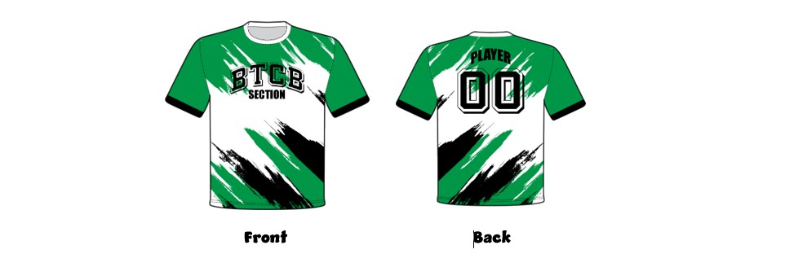

(Old) Under The Uniform Shirt-$15

(Unisex-Optional-While Supplies Last)

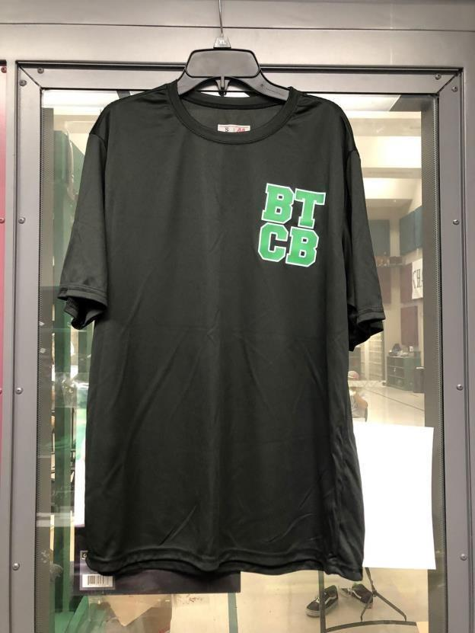

Girls Under The Uniform Shorts-$15

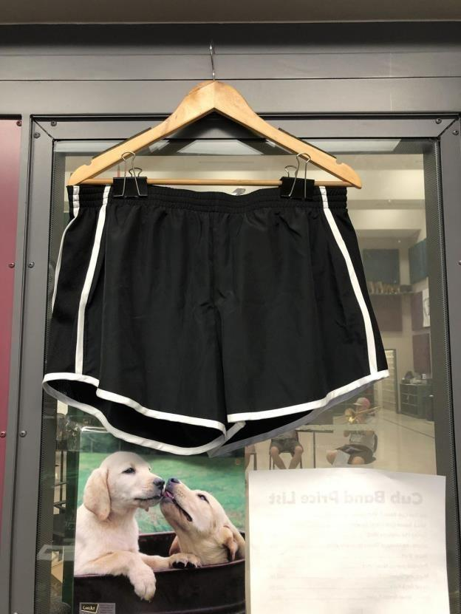

Boys Under The Uniform Shorts-$15

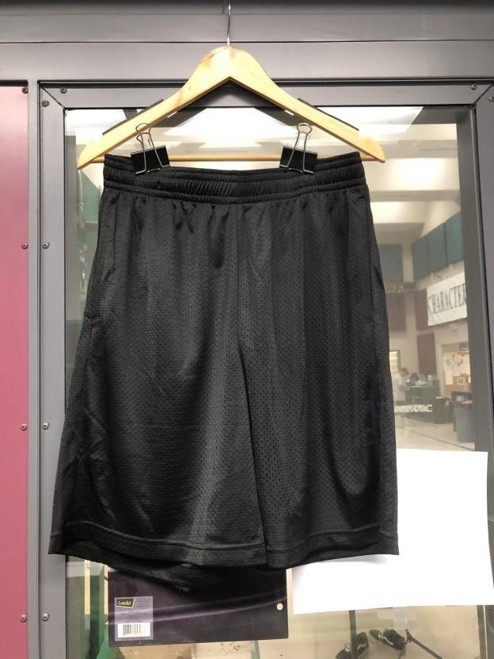

Marching Shoes-$65

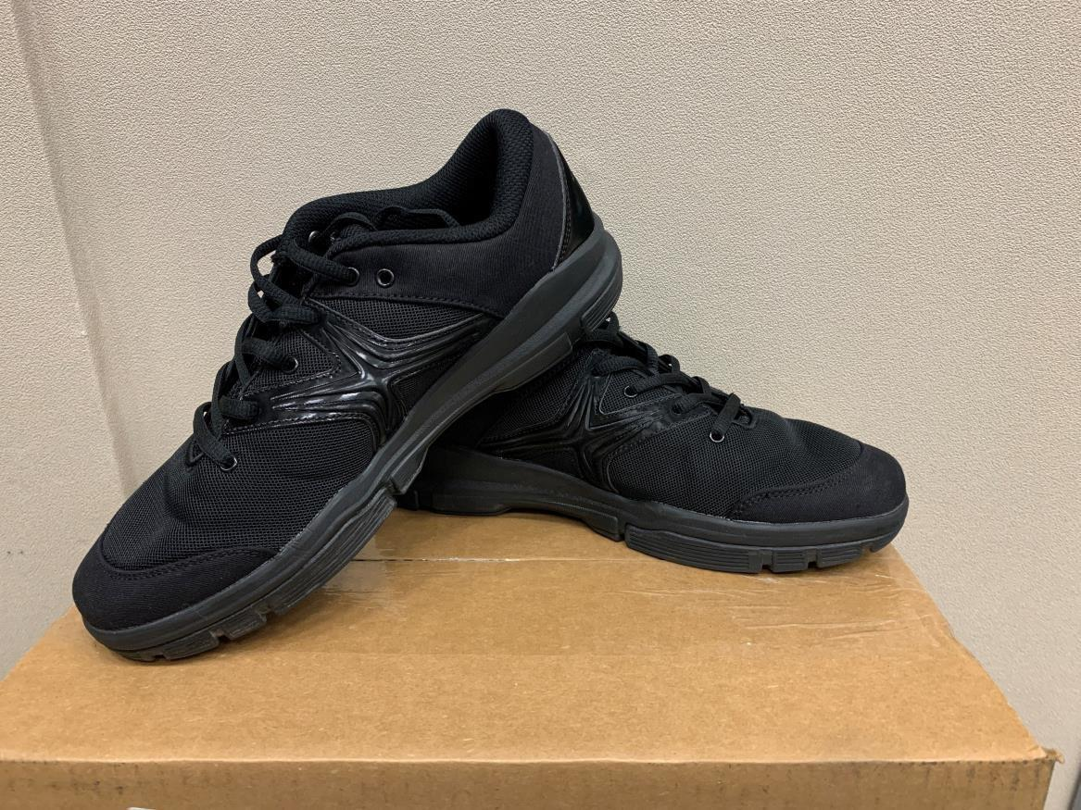

BTCB Baseball Cap-$15

(this is the hat we wear for football games).

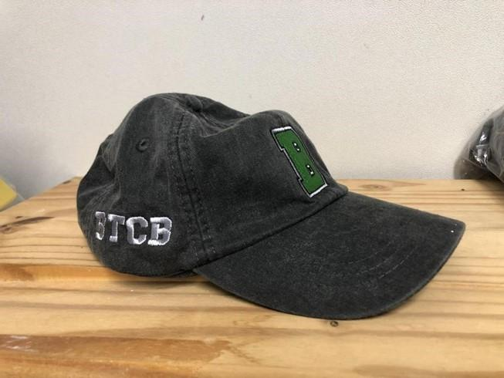

Cap - $15 (this is optional)

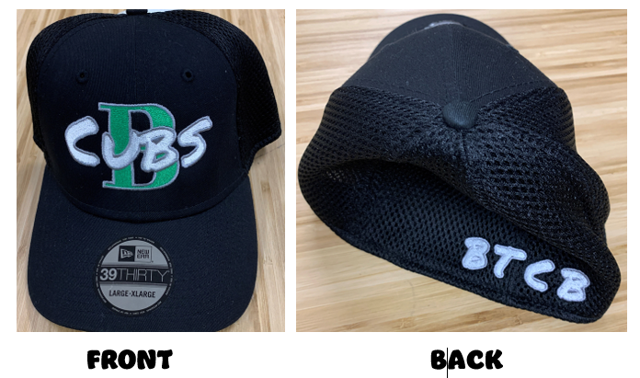

BTCB Backpack-$15

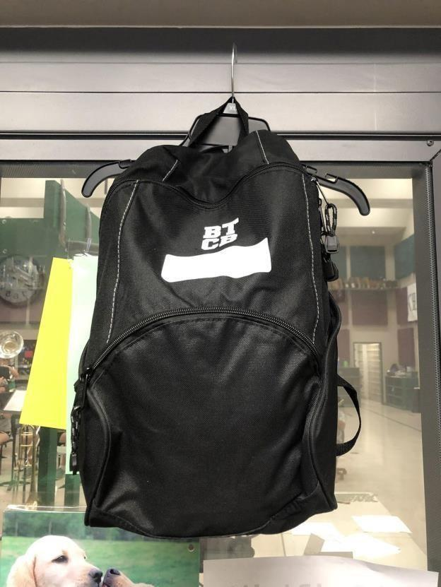

Water jug-$7 (Optional-While Supplies Last)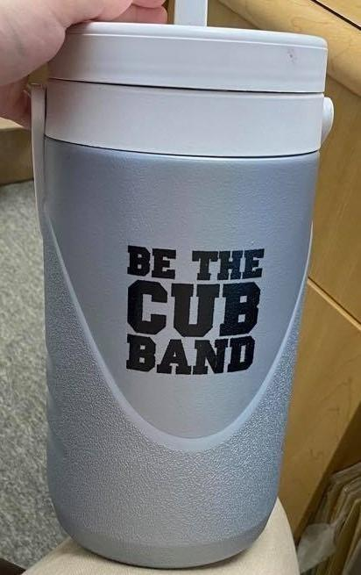

Jug Cover-$20

*(New in 2025. Everyone must have one of these to go to games and contests)*

*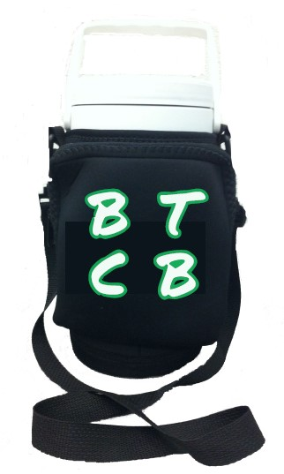*

Band Accompanist Fee - $50

Band Flip Folder with extra pages-$10