Green BTCB-$10

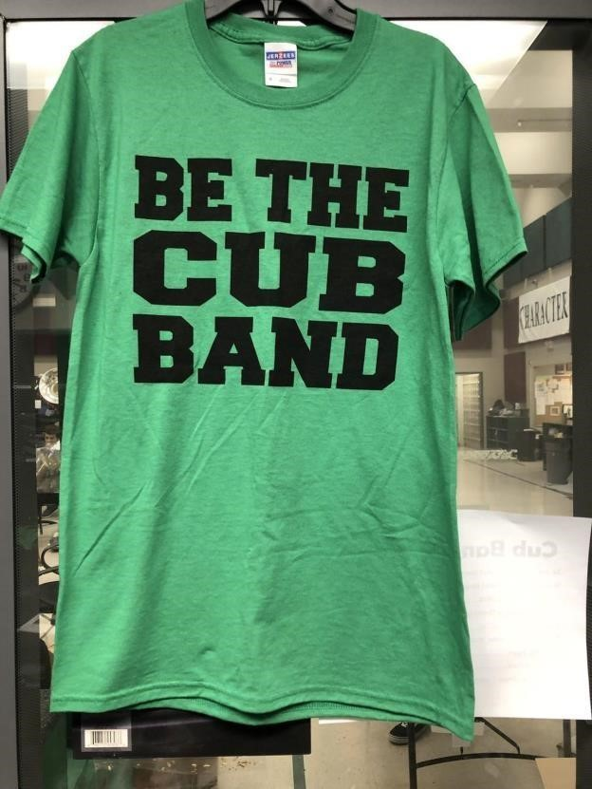

Gray BTCB-$10

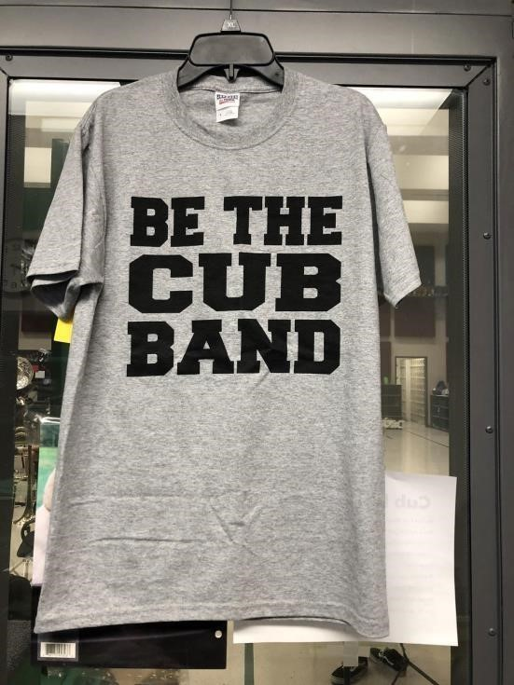

Se La Banda Cub-$10

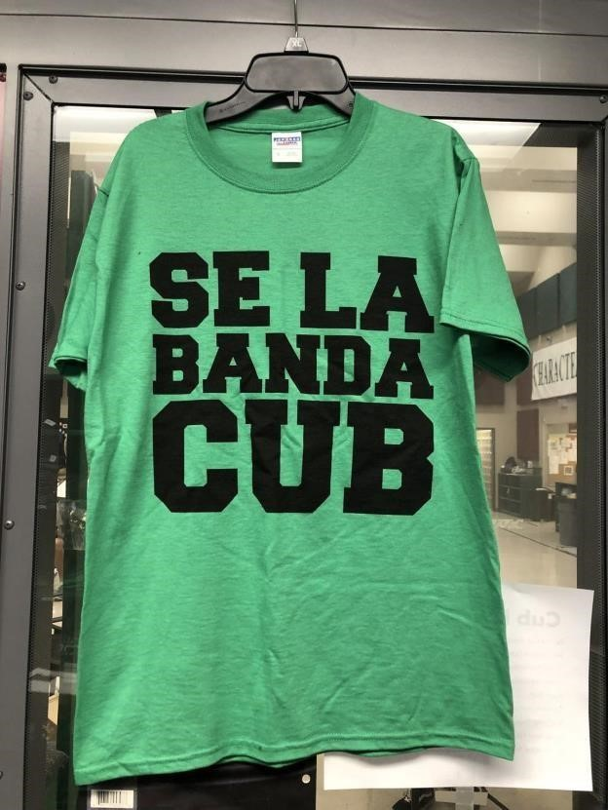

BTCB Alumni-$10

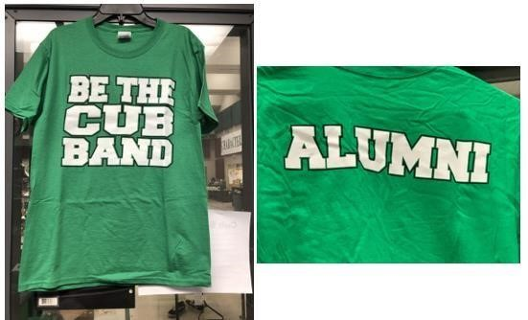

Under The Uniform Shirt-$15

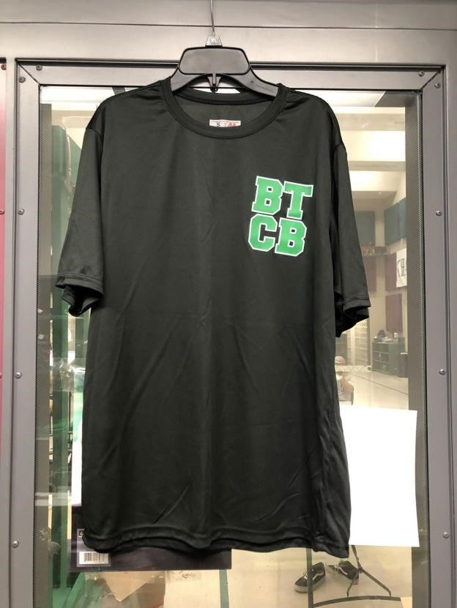

Girls Under The Uniform Shorts-$15

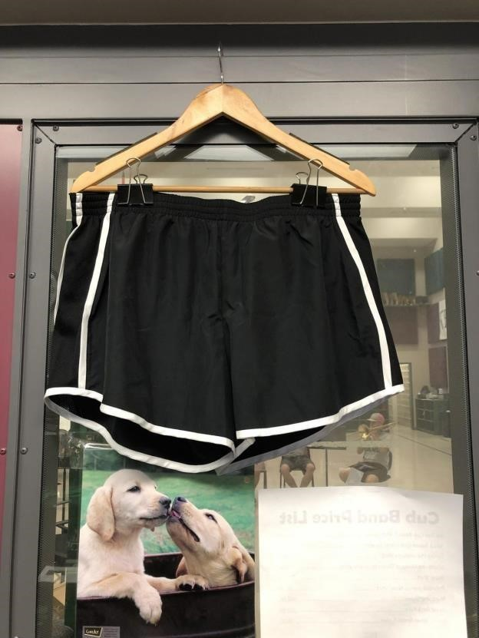

Boys Under The Uniform Shorts-$15

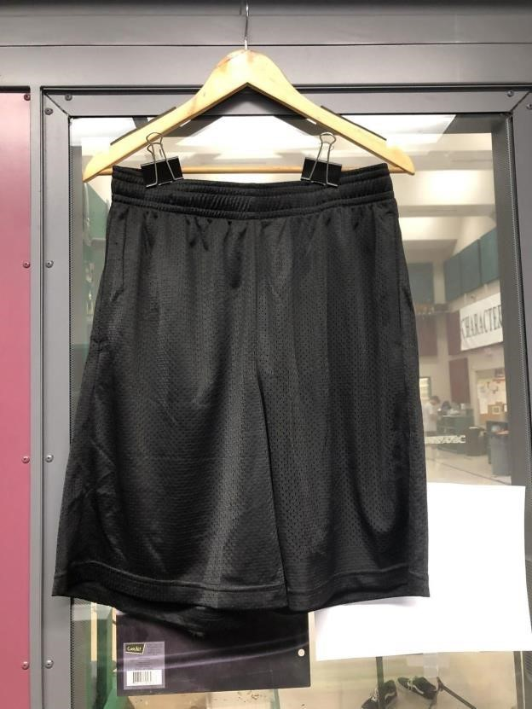

Marching Shoes-$45

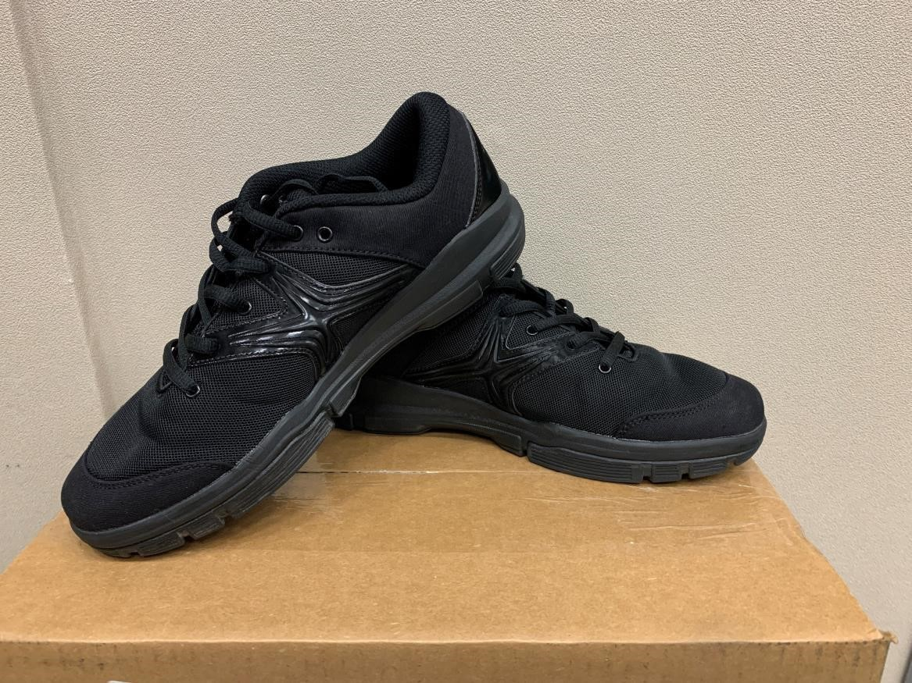

BTCB Baseball Cap-$15 (this is the hat we wear for football games).

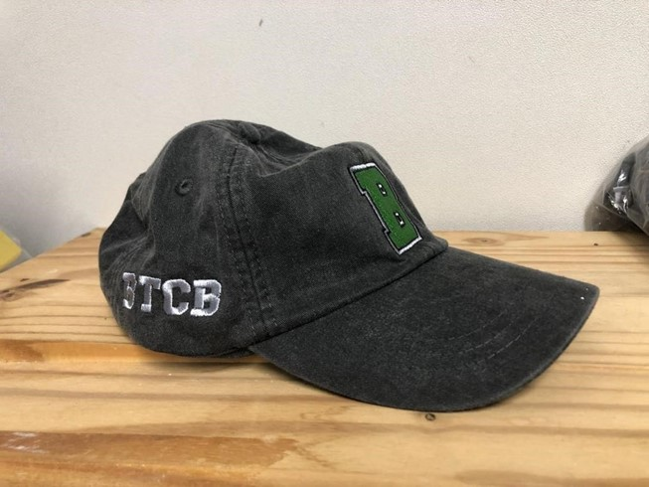

BTCB Backpack-$15

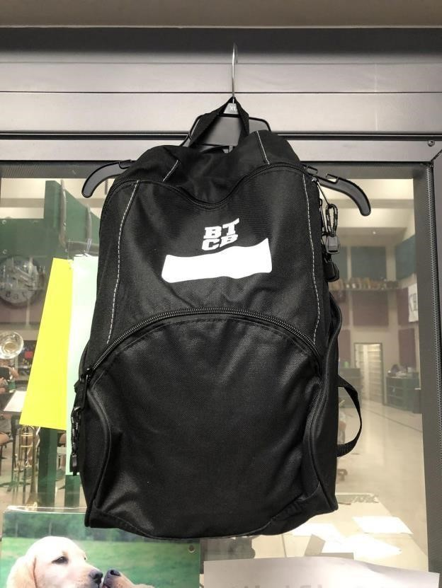

Water jug-$7

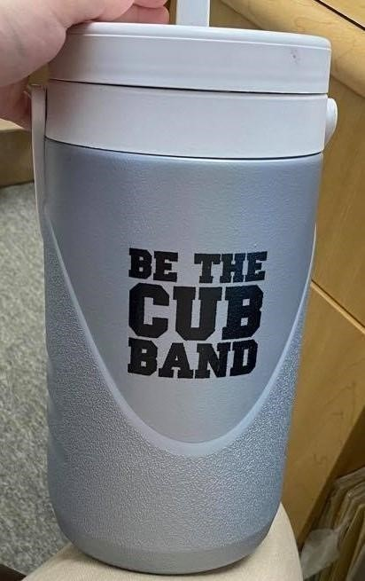

Calvera Shirt- $15

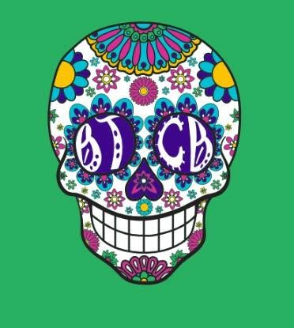

Show Shirt- $ 18

Performance Shirt- $50

Hoodie - $35

Cap - $25 (this is optional)

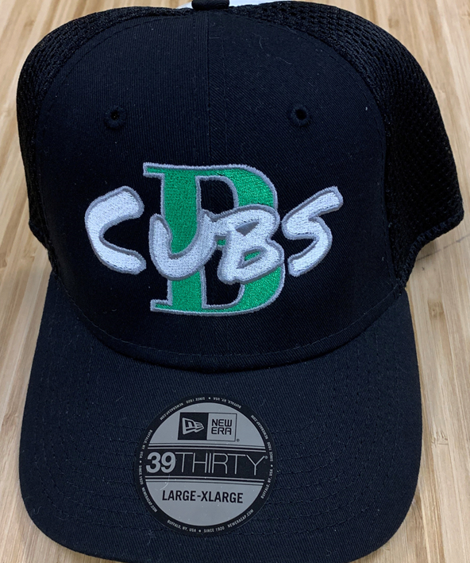

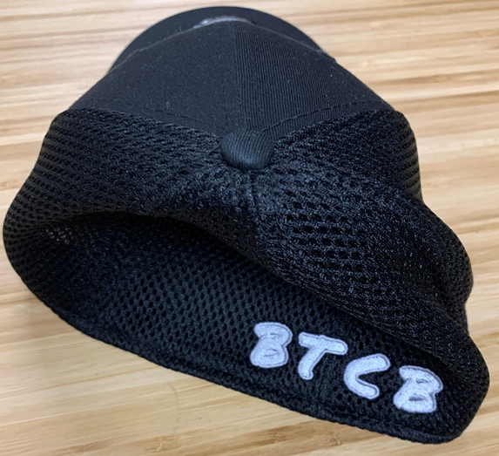

Band Accompanist Fee - $50

