Tiffin – Sentinel FFA

Fruit, Cheese, BBQ Sauce, Basket, and Nut Sale

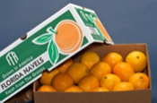Oranges

4/5 Box – Available upon request only ($42.00)

2/5 Box - Available upon request only ($25.00)

10lb. Bag - $14.00

**California NAVEL ORANGES (SUNKIST)**

Plump, seedless and loaded with juice they

taste like a real orange should, plenty sweet

and flavorful.

**Carton Size Quantity Approx. Weight**

4/5 Box 64-72 40 lbs.

2/5 Box 32-36 20 lbs.

10 lb. Bag 16-18 10 lbs.

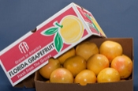Oranges

4/5 box – available upon request only ($32.00)

2/5 Box – available upon request only ($20.00)

10lb. Bag - $13.00

**RED GRAPEFRUIT (Texas)**

Naturally sweet, seedless, and ruby red in color,

this fine fruit is hand selected and guaranteed to

be the very best available.

**Carton Size Quantity Approx. Weight**

4/5 Box 32 – 36 40 lbs

2/5 Box 16 – 18 20 lbs

10 lb. Bag 7 – 9 10lbs.

[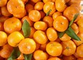](https://www.bing.com/images/search?q=mandarin+oranges&id=B7C6B1853A25010E923E112AC43CC20C1C640F23&FORM=IARRTH)

$22.00

**“ New” Mandarins or Clementines (California)**

Mandarin oranges, are some of the sweetest fruits of the orange family. A mandarin orange is a slightly smaller relative of the standard orange. These can be eaten plain or put on salads.

1/5 Bushel box Family Size box 40 -50 per box

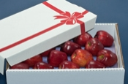

$16.00 – EverCrisp, Fuji, and Golden Delicious

.

**HONEY CRISP and MIXED APPLES**

Small to medium size, deep color, crunchy with a sweet, juicy taste.

**Carton Size Quantity Weight**

¼ BU 18-20 11 lbs. (Honey Crisp)

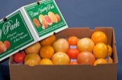

$30.00

**CITRUS TRIO PACK**

This gift pack has three kinds of juicy Florida citrus! 30 Mandarins, 16 California Navel

Oranges and 9 Red Grapefruit!

**Carton Size Size Quantity Approx. Weight**

Citrus Trio Pack 2/5 Bag About 55 pieces 20 lbs.

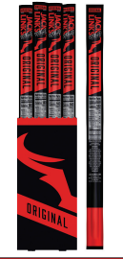

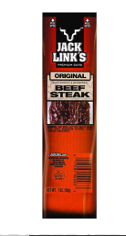

“**New**” Jack Link’s Original Beef Steak

1 oz. each

**10 packages for $20.00**

**“New”** Jack Link’s

Original Beef Stick

1 oz. each

**10 sticks for $20.00**

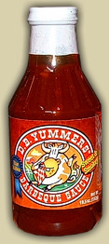

$5.00

*Other flavors available upon request for $5.00 each - Mildly Spicey and Island BBQ

Original Sweet & Smokey BBQ Sauce

Naturally fat free BBQ sauce uses no preservatives and has a recommended shelf life of two years. Packaged in 19.5 ounce recyclable glass bottles.

4-Pack

4-Pack of the original Sweet & Smokey, Mildly Spicey and Island BBQ Sauce are available.

2 – Sweet and Smokey

1 – Mildly Spicey

1 – Island BBQ



$18.00

|  |  |
| --- | --- |
|  |  |
|  |  |

[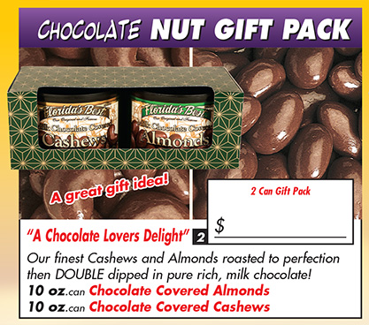](http://www.fwffb.com/FreshNuts/ChocoNutGift.asp)[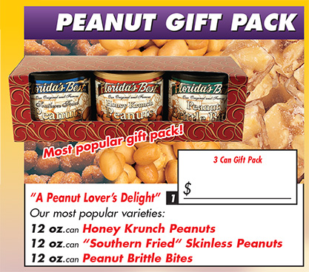](http://www.fwffb.com/FreshNuts/GiftPack.asp)

$15.00 each

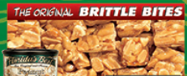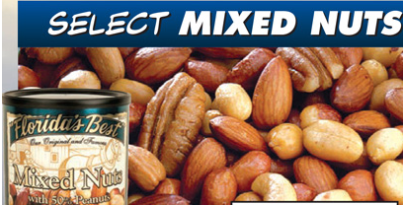

We select only the best quality and the most popular varieties of nuts. Peanuts (50%), cashews, almonds, brazils, filbert and pecans. **16 oz. can $10.00**

Our Southern style Peanut Brittle Bites are reminiscent of grandma’s homemade Copper Kettle brittle from long ago. **12 oz. for $6.00**

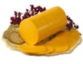 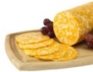 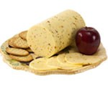 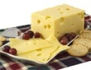 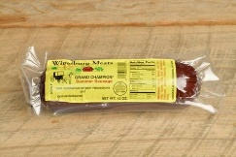

**Pearl Valley Cheese** **and Summer Sausage**– Processes in the heart in Ohio’s Amish country, these cheeses have had all the proper care and aging to make outstanding quality and taste. Each variety comes in a 3 lbs. piece, wrapped in a shrink wrap plastic to maintain quality and extend the product’s shelf life. Varieties include: Colby and Marble.

**Both varieties** come in 3lb. package - $18.00

**Mini Wheel Cheese Variety Pack** – 12 oz. Marble, 12 oz. Colby, 12 oz. Lacy Baby, 12 oz. Pepper Jack - $18.00

**Summer Sausage** – 12 oz. package - $7.00

**Small Fruit Only Basket -** A packed basket filled with: 1 pink grapefruit, 3 navel oranges, 6 maderin, 2 Golden Delicious apples, 2 EverCrisp delicious apples, 2 Fuji apples, 2 oz. of holiday candy, all wrapped in cellophane and holiday wrap, ready for the perfect gift for the holidays!

½ Peck - $14.00

**Deluxe Fruit Basket** - A packed basket filled with: 2 pink grapefruit, 3 navel oranges, 6 manderin, 2 Golden Delicious apples, 2 EverCrisp, 2 Fuji apples, 1-12oz. Wheel of Marble Cheese, 1-12 oz. Summer Sausage, 1-19.5 oz. Sweet and Smokey BBQ, 1- 16 oz. can of mixed nuts, and 2 oz. of holiday candy, all wrapped in cellophane and holiday wrap, ready for the perfect gift for the holidays!

½ Bushel Basket - $32.00

**Snack Basket** – A ½ peck basket filled with: 1-12oz. Wheel of Marble Cheese, 1-12 oz. Summer Sausage, 1-19.5 oz. Sweet and Smokey BBQ, 1- 16 oz. can of mixed nuts, and 2 oz. of holiday candy

½ Peck - $25.00

**“New” Party Pack Basket** – A ½ peck basket filled with 1-6oz. Summer Sausage, 4 Mild Beef Sticks, 1-12oz. Colby Jack Cheese, 1 Bag of Port Rinds, 1 – 19.5 oz. Sweet and Smokey BBQ Sauce, and 2oz. of holiday candy

½ Peck - $26.00